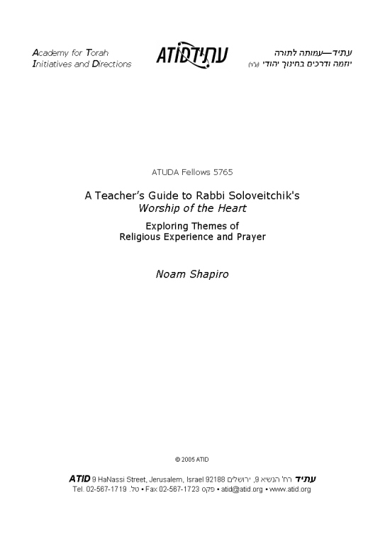
ללמד עבודה שבלב

Noam Shapiro
Atuda Fellow
5765
This teacher’s guide addresses the preface and first two chapters of Rabbi Joseph B. Soloveitchik’s Worship of the Heart: Essays on Jewish Prayer (ed. Shalom Carmy. NY: Ktav Publishing House, 2003.)

This project was initiated to serve three different educational goals. Though they certainly are mutually fructifying, these goals stand independently. Therefore, the three corresponding sections of this study guide have been developed in such a way that they may each function as a distinct unit.

Goals/Sections

- An Introduction to the thought of Rabbi Joseph B. Soloveitchik The modern orthodox community often tries to convey to its children the profundity, complexity, and spiritual sensitivity of one of its leading figureheads, Rabbi Joseph B. Soloveitchik. This text is particularly fruitful for such an endeavor in that it captures some of the Rav’s more central themes, some of his more well-known constructs in halakha and hashkafa, and it provides a wonderful example of the Rav’s poetic expository skills. Section one of this guide aims to help the teacher highlight those aspects.

- Vareity of Approaches to God High school students are at an age when they are just beginning, for the first time, to think about their identity, their life’s path, and their religious experience in a sophisticated manner. It is the duty of every Torah teacher to facilitate this soul searching and religious growth. These chapters of the Rav provide a useful context in which students can begin to ponder their relationship with God. Section two of the guide assists the teacher in meeting those ends.

- Prayer Most high school educators will agree that one of the more frustrating areas of religious instruction is prayer. Students seem to have a difficult time appreciating the spiritual potential latent in prayer. Most tefilot deteriorate into games of cat and mouse, the teacher (cop) catching the student (criminal) misbehaving in some way or another. Those that do not engage in this game run the risk, on the other hand, of tefilot being no quieter or more inspiring than a baseball game. Chapter three helps guide the teacher in the employment of the Rav’s essays in beginning to force the students to think about prayer in a more serious and sensitive way. Though no one possesses “the solution” to this challenge, section three provides one attempt at educating students about the beauty and power of tefilah.

Broader Goals and Format: Due to the direct encounter with the text, students should emerge with greater skills in reading the Rav’s writings, as well as enriched comprehension of the content. The format of this study guide aims to advance both of these goals. In all three sections, the guide facilitates discussion by offering “trigger” questions, texts, or pictures. Some of the supplements can be found in the appendices, as noted in the text. Specific selections from the primary text are highlighted as particularly significant, accompanied by questions that ensure basic comprehension as well as the crucial step of self-reflection. Basic guidelines for discussion are suggested, but, of course, each class discussion will head in a unique direction.

Note: Page and paragraph are cited as: page:paragraph. For example, “Read 4:3” informs the teacher to read page four, complete paragraph 3. (Paragraphs continued from the previous page are not included in the paragraph count.)

I.
Who was “the Rav”?
Introduction to the thought of Rabbi Joseph B. Soloveitchik

Context: The most appropriate context for this lesson would be either a class on twentieth century Jewish intellectual history or perhaps a yom iyun on the Rav, (for example, on the Rav’s yahrtzeit.) Given the context, this guide does not assume that the students have read the entirety of the chapters; instead various passages have been chosen for their ability to represent and demonstrate a key element of Rav Soloveitchik’s thought.

A.

Lead-in Questions:
- How many of you have heard of Rav Soloveitchik?
- What do you know of him?
- Why is he so important to our community?

After asking the leading questions and hearing the students responses, share with them a brief biography of the Rav:

[Here is one example, taken from the website of the Soloveitchik Institute:
Rabbi Joseph B. Soloveitchik—known as the Rav—was one of the twentieth century’s most preeminent and influential Jewish scholars. Born in 1903 in Belarus, Russia to a family renowned for its talmudic genius, and a graduate of the University of Berlin with a doctorate in philosophy, the Rav represented a halakhically-centered Orthodoxy engaged with the world.
In the early 1930s, the Rav accepted the position of Chief Rabbi of Boston, the city that remained his home until his death in 1993. In 1937, he founded the Maimonides School, an Orthodox primary and secondary school that combines rigorous Judaic and secular studies.
In the early 1940s, the Rav succeeded his father as the rosh yeshiva of the Rabbi Isaac Elchanan Theological Seminary of Yeshiva University, a position he held with great distinction until ill health forced his retirement in 1985. As rosh yeshiva, he became the spiritual mentor of thousands of American-trained rabbis and was universally acknowledged as the intellectual leader of an open and engaged Orthodoxy. His influence gained international scope due to the leadership roles he held in the Religious Zionists of America and the Rabbinical Council of America, where his wisdom guided policy decisions for nearly four decades.
The Rav wrote numerous highly influential essays and Torah discourses. He also delivered tens of thousands of public lectures and shiurim, many of which have been recorded on tape. His masterful oratory in Yiddish and English mesmerized audiences of thousands and his sophisticated writings argued powerfully for a meaningful Orthodoxy in the twentieth century. (http://www.rav.org/therav/)]

Today, we will be reading some passages from a collection of essays about prayer that were published posthumously. We begin with the preface.

B.

Read 1:1- 2:1.
The Rav expresses the idea that his religious experiences are only his alone, and it would be presumptuous to assume others share his feelings.

Significance- The Rav was unique in his emphasis of the uniqueness of every individual. Because we are all individuals, the way one person relates to God might be different than another person’s way of relating to God.

Supplementary text-

See Appendix A

C.

Read 2:2.
The Rav criticizes those philosophers who speak about Judaism from a cold, purely intellectual perspective. Judaism must be experienced in order to be understood.

Significance- Despite the (false) reputation of the Rav held by some people as a cold intellectual Talmudist, many of his writings demonstrate the passionate and emotional relationship he had with Torah and mitzvot. In fact, the Rav once divulged in a public lecture, given in 1975, that one of his greatest frustrations was that he was able to impart the intellectual information of Torah, but not the emotional side of it.

Supplementary text-

See Appendix A

D.

Lead-in Question:
1. What do you think are ways people connect to and sense God?

Paraphrase Pages 4- 10 of the chapter (See Part II of this guide for a more expanded presentation of the approaches):

The Rav begins to delineate the four basic ways a person can approach God. The intellectual path, science and Torah study, is certainly one approach. The instinctive, subjective, emotional desire for and sensing of God is another path. Third, one can relate to God through his behavior: by being a moral person who performs mitzvot. Lastly, prayer is a mode of communicating with God.

Significance- First, the Rav never thought in a simplified manner. His analysis always contains some sort of complexity, of a variety of forms. A person can relate to God in many different ways.

E.

Read 13-14:1.
In order to understand the fourth mode, tefilah, the Rav introduces us to one of his most famous chiddushim/constructs: maaseh hamitzvah and kiyum hamitzvah.

Ask-
1. What do eating matzah, eating in the sukkah, and laying tefilin share in common? (They are all essentially physical, actional mitzvot.)
2. What are other examples of this type of mitzvah?

Read 15:2 and 16:1.

Ask-
1. What do belief in God’s existence, loving God, and fearing God share in common? (They are all essentially emotional, experiential mitzvot.)
2. What are other examples of this type of mitzvah?

Read 16:2,3 (which continues onto page 17).

Ask-
1. What do simchat yom tov and aveilut share in common? (They are mitzvot that combine the physical and the emotional aspects.)
2. Why do certain mitzvot carry a physical action along with the emotional experience? (See 16:3).

The Rav calls these two elements of a mitzvah, the MAASEH and the KIYUM.

Other examples of a double-layered mitzvah include teshuva (reciting the viduy and sincere repentance) and Kriyat Shma (reciting the passages from the Torah and kabbalat ol malchut shamayim.)

Lead-in Question:
1. Given this categorization of mitzvot, where do you think tefilah fits in?

Read 19, 20:2, and 21:1.
Tefilah is a mitzvah with a MAASEH and a KIYUM shebilev.

Significance-
- The notion of Maaseh and Kiyum is one of the Rav’s many great contributions to our understanding of topics in Orach Chayim, day to day, calendar related mitzvot. While many great torah scholars over the generations produced great insights in many other areas, the Rav enjoyed forging new ground, in terms of conceptual understanding, in the realm of Orach Chayim. [If the instructor wants, here might be an appropriate place to mention the Rav’s Brisker lineage.]
- This is also an example of the Rav unifying Halakha and Hashkafa. His analysis of Halakha sheds light on Hashkafa.
- The last paragraph cited is an illustrative example of the Rav’s poetic expository skills.
Ask-
1. What is gained by the Rav’s eloquence and passion? Would this idea have had the same impact on you had he expressed his idea in a drier fashion?

F.
Read 30 and 31.

Ask-
- What is the dispute between Rambam and Ramban?
- What is a surface crisis and what is a depth crisis? Can anyone explain depth crisis in his or her own words?

Read 33:2 and 35:2.
The finitude and fundamental lack of independence that characterize human existence is the heart of the depth crisis. Bakasha, petition, is not included in our prayers primarily for its utilitarian results, but rather for the ability it grants us the opportunity to bond with God. The recognition of our dependence forces us to turn to God with an open heart.

Significance-
- The Rav’s explanation of the dispute between the Rambam and Ramban transforms it from a dry legalistic one to one about the nature of the human condition.
- The Rav’s comfort with philosophical ideas is of course apparent as well.
- The Rav changes our perception about the role of bakasha in tefilah.

Ask-
1. How does the Rav’s conception of bakasha make you feel? Do you agree or disagree?

Conclusion: This selection from the Rav provides a wide range of ideas which can help introduce the student to the Rav’s thought.

II.
Connecting
Different Ways of Approaching God

Context: This lesson is appropriate for a class in Machshevet Yisrael or simply for a one-time discussion about a topic very relevant to every student’s religious life. This section is designed as a lesson plan in which the students first read the chapter on their own, and then enter the classroom for discussion and analysis.

A. The Set-Up

Lead-in activity: Show the students the 7 pictures [See Appendix B].

Ask-
Which picture, do you think, depicts the most authentic and most effective way of approaching God?

This question, obviously, is intended to serve as a springboard for conversation. There is no correct answer. Have the students debate the various approaches. As we will see, the Rav will argue that all of these are legitimate avenues.

After conducting this initial conversation, assign pages 3-12 as a homework assignment to read in advance for the next class. (It is advisable to allow for a few nights to read and digest this material.)

B. Intellectual

Read the Rambam, in Hilkhot Teshuva 10:6. [See Appendix C]
Study the text together.

Ask-
1. What does “al pi hadeah tihiye hahava” mean?
2. Why is that true- the more you understand, the more you can love?
3. Can you think of any examples of this in inter-human relationships as well? [Ex-you don’t marry someone unless you have dated and grown to truly know that person.]

Read the first paragraph of the section entitled “The Intellectual Medium,” on page 4.

What does the Rav describe as the two primary forms of an intellectual approach?

Ask-
4. What does the Rav describe as the two primary forms of the intellectual approach? [“scientific-metaphysical research and knowledge” and “the study of the Torah”]
5. Which of these two do you think is the more effective path with respect to man’s understanding of God?

It is interesting to note that the Rav explicitly states his opinion on this question.

Read the last paragraph of the section, on page 5.

6. Why would Torah be “the most sublime” path on the intellectual plane?
7. What do you think of the Rav’s assessment?

C. Emotional

Read the 3 quotes from Rebbe Nacman of Breslov. [See Appendix C]
[Optional- play a Jewish song from a CD]

Ask-
- How is the approach offered by Rebbe Nachman different than what we read in the Rambam?
- Do you ever find that music can bring you closer to God?
- What are other non-intellectual, emotional ways of sensing God’s presence? [Nature, art, instinct, love of family, etc.]

Read the first paragraph of the section entitled, “The Emotional Medium.”

Ask-
- The Rav mentions that a person can reach God emotionally in times of “joy and jubilation,” as well as in times of “loneliness and despair”. How is it possible that these contradictory human experiences can both lead to a person relating to/approaching God?

Read the second paragraph on page 8.

Ask-
- How does the Rav explain the dispute between Rambam and Kuzari? Does the Rambam see any place for emotion? Does the Kuzari see room for the intellect?
- Between which two extreme poles, according to the Rav, does Halakha try to balance itself?
- Where do you personally see yourself along this spectrum of emotion and intellect, of “cognition and feeling”?

D. Volitional

Read the quote from Rashi and the Rambam. [See Appendix C]

Ask-
- What does this statement suggest as a proper attitude when it comes to keeping mitzvot that conflict with your instinctive desires?
- What might you have thought would be the proper approach?
- Why do you think this type of approach is recommended?

Read from the section entitled “The Volitional Medium,” from the bottom of page 9, the last sentence on the page (that begins with the words “One serves God…”) Continue reading until the end of the section on page 10.

Ask-
4. The Rav claims that by making moral decisions and performing moral acts, man “enters into an intimate relationship with [God]. How does a relationship with God develop by doing those things that the Rav outlines?
5. How does the Rav’s formulation, “by disciplining oneself, by taming one’s animal desires and impulses,” relate to the maamar Chazal with which we began this section?
6. What is another way of saying “cult and ethos”? [ceremonial mitzvot and moral-ethical mitzvot]
7. What does the Rav infer from the nature of the asseret hadibrot?
8. Does this mode of identification with God resonate with you? Do you ever feel close to God in this way? Review again the list at the top of page. 9. Which of these items do you find most meaningful, most directly linking you to God?

E. Dialogical

Read the quote from Tehillim. [See Appendix C]

Ask-
- What important theological truth do these pesukim teach us? [God hears our prayers]

Read page 10, the first paragraph in the section entitled “The Dialogical Medium.”

Ask-
2. How do prayer and prophecy mirror each other?
3. Do you feel that God is listening when you speak to Him?

Read 12:1.
Ask-
- What, according to the Rav, is the most important element in our prayers? Why? [Petition. Not necessarily in order to gain what we want, but to express and reinforce our feeling of utter lack of independence.]
- Did you ever think of bakasha in our tefilot in this way?
- Why is it important to emphasize our dependence on God?

F. Wrap Up

At this point, hopefully the students have achieved a more sophisticated appreciation of what it means to approach God and to develop pa relationship with Him. Numerous ways of connecting to God are available. End the lesson with a wrap up discussion:

Ask-
- What do you find to be the most meaningful approach?
- Are there any other categories of approaching God that you can think of?
- What kind of challenges do we face that can make it difficult at times to connect to God?
- How can we work on improving our ability to sense and encounter God?

III.
Petition in Prayer
Exploring the Meaning of Prayer

Context: This lesson plan is relevant to a formal Biur Hatefilah class, as well as a one-time tool in the always- relevant challenge of educating students about the meaning and potential of prayer.

A.

Lead-in Questions:

- What is prayer?
- Do you sometimes have a “better” tefilah and a “worse” tefilah?
- If so, what factors lead to those opposite experiences?
- What do you find challenging about tefilah?
- Is there anything you wish you could discuss or learn about, that you feel would help your tefilah be a more meaningful experience?

After hearing some of the students’ perspectives, introduce the essay of the Rav, entitled, “Prayer, Petition and Crisis.” Inform the students of the goal in reading this essay: hopefully, though it might not address all of the issues that have been raised, reading the essay will begin to help them look at tefilah in new ways, from a fresher and perhaps richer perspective.

It is recommended that students be given the essay to read individually over the course of a few days. [One suggestion would also be to skip pages 22-25, to ease an already somewhat daunting read for many students.]

B.

The beginning of the essay focuses on the central construct of Maaseh vs. Kiyum and where Tefilah fits in to that. (Note: parts of the following section appear above, in section I.E, as well.)

Ask-
1. What do eating matzah, eating in the sukkah, and laying tefilin share in common? (They are all essentially physical, actional mitzvot.)
2. What are other examples of this type of mitzvah?

3. What do belief in God’s existence, loving God, and fearing God share in common? (They are all essentially emotional, experiential mitzvot.)
4. What are other examples of this type of mitzvah?

5. What do simchat yom tov and aveilut share in common? (They are mitzvot that combine the physical and the emotional aspects.)
6. Why do certain mitzvot carry a physical action along with the emotional experience? (16:3).

The Rav calls these two elements of a mitzvah, the MAASEH and the KIYUM.

Other examples of a double-layered mitzvah include teshuva (reciting the viduy and sincere repentance) and Kriyat Shma (reciting the passages from the Torah and kabbalat ol malchut shamayim.)

7. Given this categorization of mitzvot, where do you think tefilah fits in?

Read 19, 20:2, and 21:1.
Tefilah is a mitzvah with a MAASEH and a KIYUM shebilev.

The Rav describes the balance between the external act and the internal, subjective experience.

8. How do you deal with the sometimes conflicting forces of objective, fixed text, and subjective, ephemeral feelings? Is this a tension? How can we better integrate our emotions with the standardization of tefilah.

C.

Read the section entitled “Is Prayer for Everyone?” on pages 26-27.

Ask-
- What problem is the Rav addressing when he asks, “is prayer for everyone?”
- Do you ever wonder the same thing?
- If so, why do you think prayer might not be for everyone?

Review the Rav’s analysis of the centrality of tzarah and petition to prayer. Discuss the dispute between the Rambam and Ramban, and the Rav’s explanation of it. (Pages 28-33)
Most probably, the students will be able to more easily grasp the concept of surface crisis. If so, skip to question 5 for a further elaboration of the “depth crisis” and then return to question 4.

Have students offer examples of surface crisis vs. depth crisis.

- Do you ever experience either of these crises?

Read 34:2.

5. What is the essence of the “depth crisis”?
6. What do you think the Rav means when he says on page 33, at the
beginning of the section, that a person can exert effort to more deeply get in touch with his depth crisis? How is this accomplished?

Read 35:2.

7. What do you think of the Rav’s assertion that the purpose of prayer is not to attain our “wish list” but rather to establish a fellowship between man and God? Why do you think that the Rav asserts that the primary purpose of prayer is NOT the fulfillment of those requests? [Possible answers: Not all prayers are in fact answered in the affirmative; why would God need us to articulate our needs – doesn’t He know them already?; the Rav’s explanation may lend more profundity to petition, for some people.]

8. Do you think the Rav has successfully shown that prayer is for everyone?
D. Wrap Up

9. Does this essay help you with any of the issues you have raised before we read the essay?

10. In light of this essay and beyond it, what are some ways we can help make our tefilot more meaningful?
`

APPENDIX A

1.
ברכות (נח.)
ת"ר הרואה אוכלוסי ישראל אומר ברוך חכם הרזים שאין דעתם דומה זה לזה ואין פרצופיהן דומים זה לזה

2.

Let me make an admission here; I will confide in you. This is the toughest of all jobs, the most difficult of all tasks. I know from my own experience how difficult it is. I am not modest; I am far from being modest. I know that I am a good teacher. I can teach halakha. I can explain the most abstract concepts. I can popularize the most complex Talmudic debate and break it down into its component parts. I can explain and elucidate abstract ideas.

For instance, before Rosh Hashana and Yom Kippur I used to study with my students…the halakhot pertaining to the Yomim Noraim….

But one trick I have not mastered. One thing I can not do to perfection is to tell my students how I felt on Rosh Hashana and Yom ha-Kippurim when I was their age. The emotions that I experienced, and not what I knew about it. I knew a lot and they know a lot. But what I felt on these days! I am unable to share with them what I experienced, for instance, when the shaliakh tzibbur [cantor] used to chant and sing…

[Rakeffet-Rothkoff, Aaron. The Rav: The World of Rabbi Joseph B. Soloveitchik, v2. Ed. Joseph Epstein. Ktav: NY, 1999. 178-179]

APPENDIX B

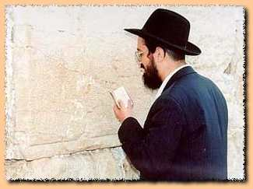

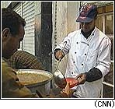
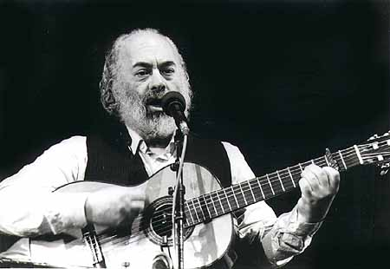

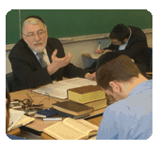



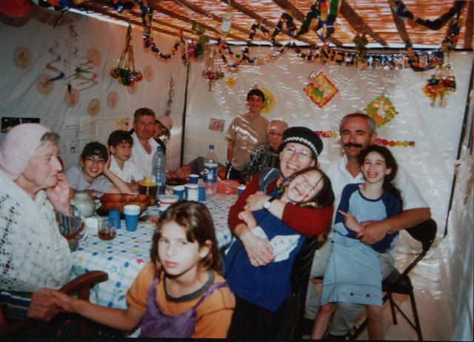



APPENDIX C

Intellectual
רמב"ם הלכ' תשובה י:ו
דבר ידוע וברור שאין אהבת הקדוש ברוך הוא נקשרת בלבו של אדם, עד שישגה בה תמיד כראוי ויעזוב כל שבעולם חוץ ממנה כמו שציווה ואמר "בכל לבבך ובכל נפשך". אינו אוהב הקב"ה אלא בדעת שיידעהו. ועל פי הדעה תהיה האהבה אם מעט מעט, ואם הרבה הרבה.
לפיכך צריך האדם לייחד עצמו להבין ולהשכיל בחכמות ותבונות המודיעין לו את קונו כפי כוח שיש באדם להבין ולהשיג, כמו שביארנו בהלכות יסודי התורה.

Emotional
Quotes from Rebbe Nachman of Breslov

The joy we experience on the three annual festivals can arouse new perceptions of Godliness (Likutey Moharan 30:5).

A holy melody has the power to bring one to the level of prophecy. Music is the foundation of true attachment to God (1:3.)
Music has a tremendous power to draw you to God. Get into the habit of always singing a tune. It will give you new life and send joy into your soul. Then you will be able to bind yourself to God. It is especially good to sing on Shabbat and the festivals, and at a wedding celeration (Rabbi Nachman's Wisdom #273).

Volitional
רשי ויקרא כ:כו
רבי אלעזר בן עזריה אומר מנין שלא יאמר אדם נפשי קצה בבשר חזיר אי אפשי ללבש כלאיםאבל יאמר אפשי אבל מה אעשה ואבי שבשמים גזר עלי ת"ל ואבדיל אתכם מן העמים להיות לי שתהא הבדלתכם מהם לשמי פורש מן העבירה ומקבל עליו עול מלכות ש מים.

רמב"ם הלכ' תשובה פרק ה
א רשות כל אדם נתונה לו: אם רצה להטות עצמו לדרך טובה ולהיות צדיק, הרשות בידו; ואם רצה להטות עצמו לדרך רעה ולהיות רשע, הרשות בידו. הוא שכתוב בתורה "הן האדם היה כאחד ממנו, לדעת, טוב ורע" (בראשית ג,כב)--כלומר הן מין זה של אדם היה אחד בעולם, ואין לו מין שני דומה לו בזה העניין, שיהא הוא מעצמו בדעתו ובמחשבתו יודע הטוב והרע ועושה כל מה שהוא חפץ, ואין לו מי שיעכב על ידו מלעשות הטוב או הרע. וכיון שכן הוא, "פן ישלח ידו" (שם).
ב אל יעבור במחשבתך דבר זה שאומרים טיפשי האומות ורוב גולמי בני ישראל, שהקדוש ברוך הוא גוזר על האדם מתחילת ברייתו להיות צדיק או רשע. אין הדבר כן, אלא כל אדם ואדם ראוי להיות צדיק כמשה רבנו או רשע כירובעם, או חכם או סכל, או רחמן או אכזרי, או כיליי או שוע; וכן שאר כל הדעות.
ג ואין לו מי שיכפהו ולא גוזר עליו, ולא מי שמושכו לאחד משני הדרכים, אלא הוא מעצמו ומדעתו נוטה לאיזה דרך שירצה. הוא שירמיהו אומר "מפי עליון לא תצא, הרעות והטוב" (איכה ג,לח)--כלומר אין הבורא גוזר על האדם לא להיות טוב, ולא להיות רע.

Dialogical

תהלים קטז

אָהַבְתִּי כִּי יִשְׁמַע ה' אֶת קוֹלִי תַּחֲנוּנָי.
כִּי הִטָּה אָזְנוֹ לִי וּבְיָמַי אֶקְרָא.

For Further Reading

Finkleman, Yoel. Ed. Notes from Atid: Educating Toward Meaningful Tefillah, 2001.

Rakeffet-Rothkoff, Aaron. The Rav: The World of Rabbi Joseph B. Soloveitchik. Ed.
Joseph Epstein. Ktav: NY, 1999.

Author Bio

Noam Shapiro is completing his ordination at RIETS and his MA in Jewish History at Bernard Revel Graduate School at Yeshiva University. He has taught at the Frisch School and will be teaching at Bet Sefer Fuchs Mizrachi.

